
KIRINYAGA UNIVERSITY
SPI 2301- WEB APPLICATION DEVELOPMENT II
Assignment 2
- Using code snippet explain three variable scopes used in PHP.
- Using a diagram explain the components and interactions of a 3-tier client server architecture.
- Differentiate between a session and a cookie as used in PHP scripting.
- Write down the code that would store firstname text field inside a session variable.
- Write a PHP script to create a cookie named “Admin” and assign the value (firstname) to it; also specify the expiry as 4 hours.
- Discuss two functions used to validate form data in PHP.
- Write HTML code that will display the below table on a web page.
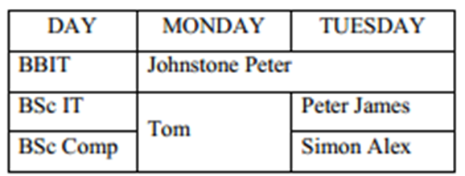
- Use illustrations to explain the difference between GET and POST methods.
- A School wishes to develop a website to allow teachers enter marks online. Design a sticky form to enter Student Name, Mathematics, English and Kiswahili marks with appropriate form attributes to send marks to a PHP file.
- Consider the function: substr($string, $start, $length);
  - Using an example explain the purpose of the above function.
  - Explain the purpose of the parameters ($start, $string and $length) in the function.
- Using code snippet show ways in which arrays can be created in PHP.
- Before using a MySQL database you need to connect and log in to the server where the database is located. Write a PHP code to connect a database named HRDatabase in a XAMPP database server.

